SOP FOR Download Tool

1、Click Download Agent Enter into sw folder Select “MTK_AllInOne_DA.bin”

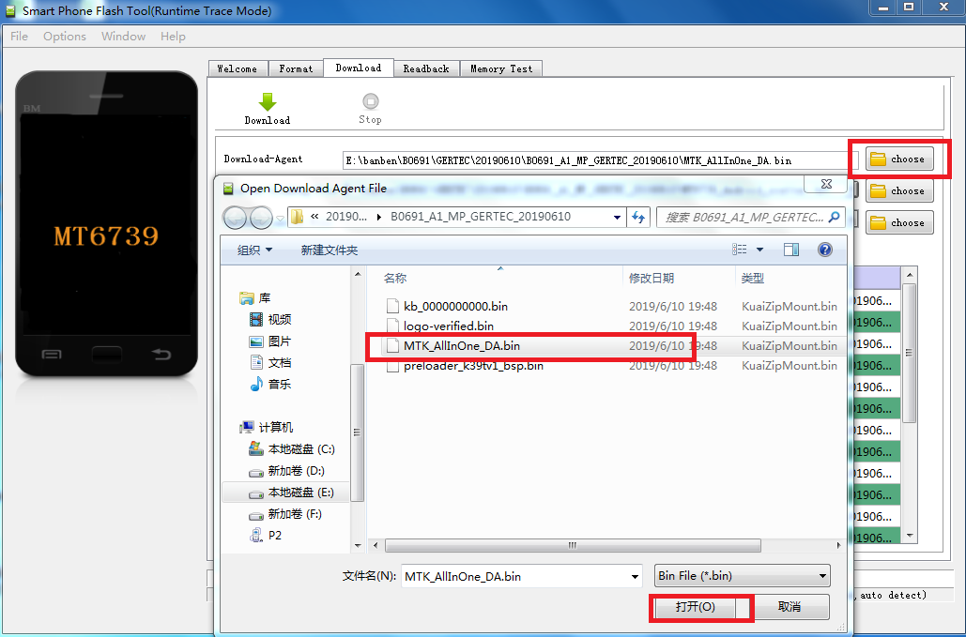

2. Choose scatter file. Do not choose Authentication file.
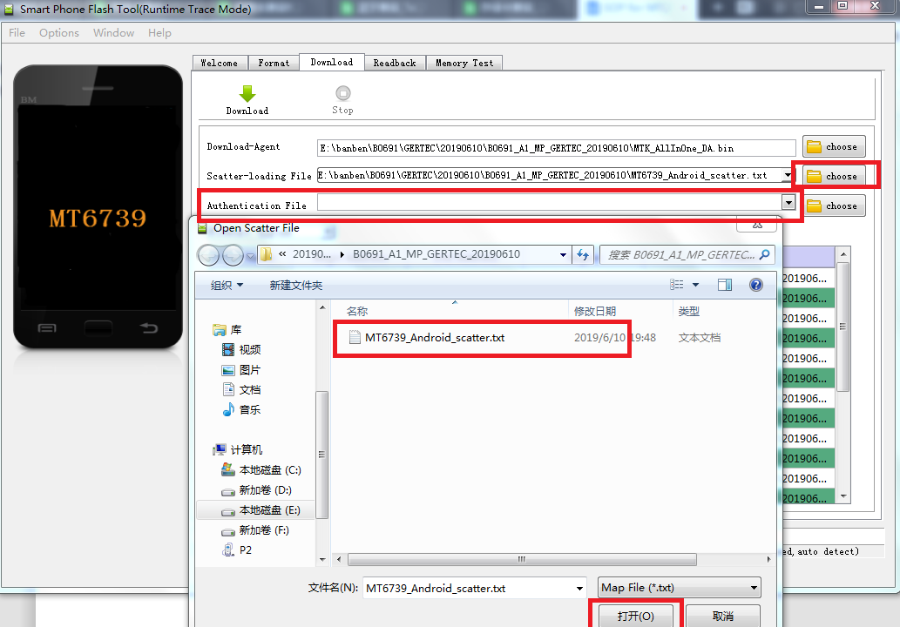

3. Choose Firmware Upgrade and start flash device.

